Youth For Christ International East Africa Region

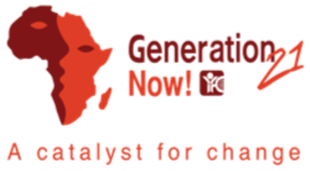

Second term Ministry Report 2025

April-June 2025

**Luc DUHIMERUGABA**

**YFC International**

**East Africa Region Regional Director**

**Kigali Rwanda**

## 1 Introduction

This second term (April-June 2025) report provides ministry updates at Youth For Christ International East Africa Region. Around 193,541 young people were reached with the Gospel in these 3 months (April-June 2025) compared to 175,161 young people reached from January to March 2025 (First term). YFC Nations have reached roughly 10.5% more young people from April to June 2025 compared to January -March 2025. This suggests that the ministry of reaching young people with Gospel has been particularly effective.

There has been also an improvement in making weekly visits. Around 47,901 young people were visited on weekly basis in April-June 2025 compared to 42, 843 young people in previous term. The youth visited on weekly basis increased by 11.8%, which suggests that YFC nations have enhanced weekly engagements with the young people.

There has been a modest increase in providing opportunities for young people to make decisions. In the second term, approximately 172,410 young people were given the opportunity, compared to 167,241 in the first term. This represents an increase of about 3.1%. This slight improvement indicates that the ministry is making progress in offering young people the chance to make decisions to follow Jesus Christ. However, there is still potential for further growth and enhancement in this area.

At a regional level, there has been a significant increase of 41.1% increase in number of young people responding to the Gospel, that is from 45,369 in Jan-March 2025 to 65, 443 in April-June 2025. This suggests YFC nations poured substantial efforts into their evangelistic and discipleship endeavors during this second term of the year.

Table 1: Ministry Statistics 2025

|  |  |  |  |  |
| --- | --- | --- | --- | --- |
| No | Ministry activities | Jan-March 2025 | April-June 2025 | Percentage change (%) |
| 1 | Young people reached through YFC Ministry | 175,161 | 193,541 | 10.5% |
| 2 | Youth visited on weekly basis | 42,843 | 47,901 | 11.8% |
| 3 | Youth given the opportunity to make a decision | 167,241 | 172,410 | 3.1% |
| 4 | Youth responding to Gospel | 46,369 | 65,443 | 41.1% |

## 

## 2 Ministry Performance in East Africa

### 2.1 Youth Reached through ministry

YFC nations in East Africa region reached the youth with various ministry models. Kenya has reached around 83, 000 young with Gospel. South Sudan reached around 51,400 young. Tanzania reached around 28,000 youth . YFC Rwanda reached around 14,000 young people. DRC reached around 491 young people (Figure 1). This implies that there is a variation in reaching the youth with the Gospel in East Africa region. Kenya and South Sudan have been effective in doing evangelistic ministry in reaching a large number of the youth, while DRC has relatively reached few number of the youth.

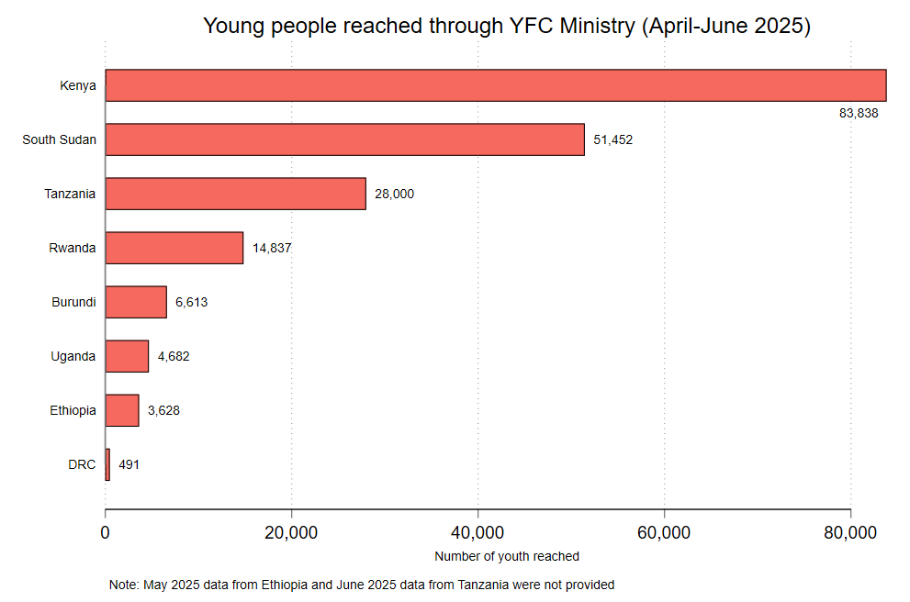

Figure 1: Young reached with the Gospel

### 2.2 Youth visited on weekly basis

On a weekly basis, Kenya visited around 17, 200 young people. South Sudan visited also around 8,900 young people. Tanzania also visited 7000 young people. Burundi and Rwanda visited on weekly basis around 6, 519 and 6,193 respectively. Ethiopia visited around 1,794 young people. DRC visited around 220 young people. YFC Uganda did not visited young people on weekly basis. Figure 2 indicates the significant variation in weekly outreach efforts across all YFC nations. Kenya and South Sudan have been active in weekly active, while DRC and Uganda have the lowest numbers.

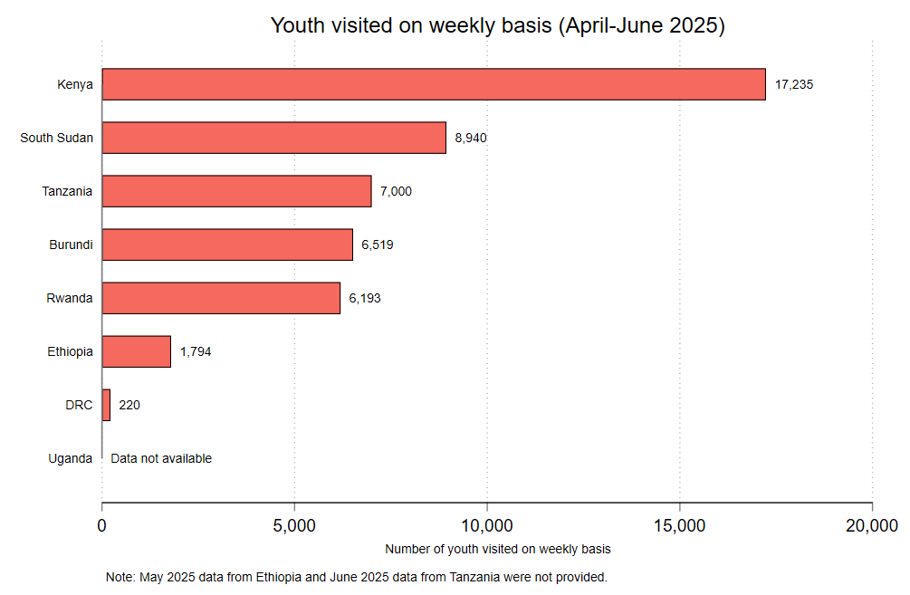

Figure 2: Young people visited on a weekly basis

### 2.3 Youth making decision to follow Jesus

Figure 3 indicates the number of young people that made the decision to follow Jesus. Kenya has the largest number of young that made the decision (76,329 young people). South Sudan had around 51,452 young people. Tanzania gave the opportunity to around 26,500 young people. Ethiopia had less than 200 young people. There is high substantial variation in the number of young people making decision across all YFC nations. Kenya and South Sudan had a notable and higher number compared to other nations.

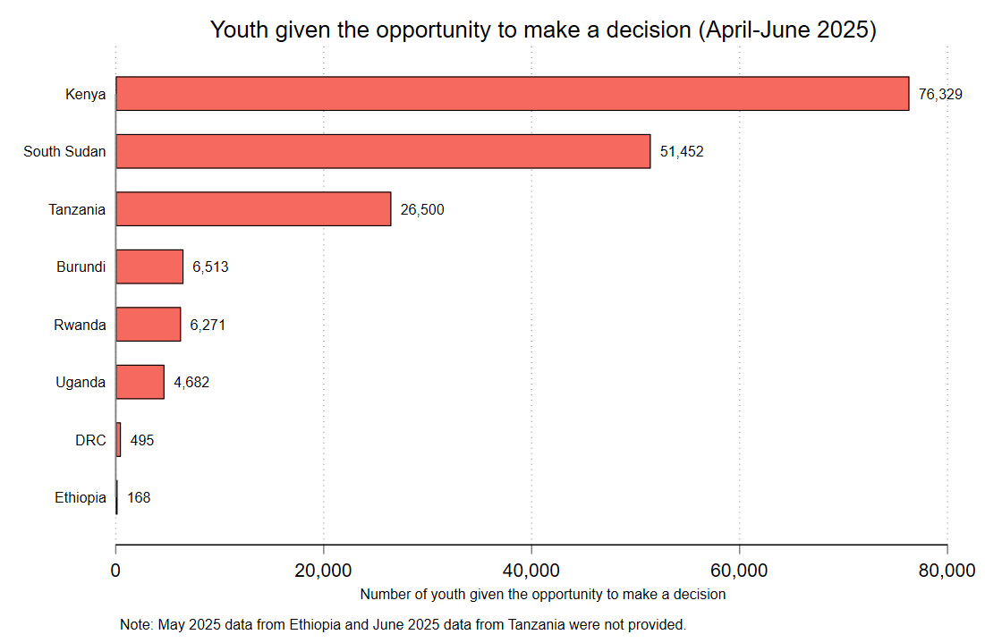

Figure 3: Young people given the opportunity to make decision

### 2.4 Youth responding to Gospel

Young people responded to the Gospel. Tanzania, Kenya and South Sudan had the large number of youth responding to the Gospel, while Burundi and Rwanda had both around 500 young people, and Uganda, DRC and Ethiopia had less than 400 young people that responded to Gospel. It is apparent that there has been significant variation of responses to Gospel across YFC nations.

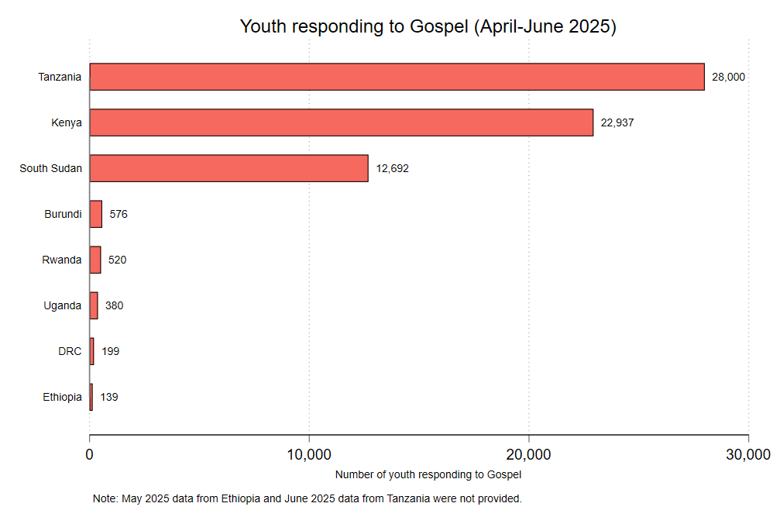

Figure 4: Young people responding to Gospel

This performance was made possible due to the presence of staff and volunteers. The following table indicates the number of volunteers and staff per each nation by June 2025

Table 2: Staff and Volunteers

|  |  |  |  |  |  |  |  |  |  |
| --- | --- | --- | --- | --- | --- | --- | --- | --- | --- |
| Staff & Volunteers | Burundi | DRC | Ethiopia | Kenya | Rwanda | South Sudan | Tanzania | Uganda | Total |
| Staff | 226 | 6 | 9 | 32 | 244 | 8 | 10 | 11 | **546** |
| Full time volunteers |  | 6 | 7 | 10 | 11 | 16 | 25 | 25 | **100** |
| Part-time volunteers | 37 | 20 | 37 | 105 | 480 | 20 | 70 | 25 | **794** |

## 3 Ministry Achievement

### 3.1 Evangelism and Discipleship

3.1.1. Youth For Christ Rwanda and School of Leadership and Discipleship

In this April 2025, 28 students have graduated from School of Leadership and Discipleship Programme of YFC/Rwanda. These new graduates contribute to the growing alumni network, which now totals around 430 individuals since the inception of the SLD programme.

|  |  |
| --- | --- |
|  |  |
| ***SLD 2024-2025 Cohort graduates*** | ***SLD graduates with their parents, siblings and friends*** |

The table indicates that YFC EAC nations have consistently conducted more evangelism activities than discipleship activities over the three months. In April 2025, there were 26 evangelism models used compared to 18 discipleship models. This trend continues in May and June, with 24 and 23 evangelism models respectively, compared to 16 and 18 discipleship models.

Table 3: Ministry Models

|  |  |  |  |
| --- | --- | --- | --- |
| Month | Evangelism Models | Discipleship Models | Young people responding to Gospel |
| April 2025 | 26 | 18 | 11,408 |
| May 2025 | 24 | 16 | 41,203 |
| June 2025 | 23 | 18 | 12,832 |

In May 2025, there has been a substantial increase, with 41,203 young people responding to the Gospel, compared to 11,408 in April 2025 and 12,832 in June 2025. The increase in May 2025 suggests that the evangelism efforts during that month were particularly effective or that there were specific events or campaigns that led to a higher response rate.

Table 3 suggests that while evangelism activities are more frequently conducted than discipleship activities, there is a notable fluctuation in the effectiveness of these activities as indicated by the response to the Gospel. The significant increase in responses in May 2025 indicates a potential opportunity to analyze and replicate the ministry strategies used during that month to enhance the impact of future evangelism efforts.

|  |  |
| --- | --- |
| VBS in April 2025 in YFC Kenya | Youth Camp in YFC-Kenya |
| VBS in April 2025 in YFC Kenya | Youth Camp in YFC-Kenya |

The following table indicates the some of the evangelism and discipleship models that YFC East Africa nations used to minister to young people.

*Table 4: List of evangelism and discipleship Models*

|  |  |
| --- | --- |
| Evangelism Models | Discipleship Models |
| * Movie (Jesus Film), Gospel through Cinema; * Sports, door-to-door, one-on-one, relational & street, friendship evangelism * Vacation Bible School; * Outreaches * Music & Dance | * Reading discipleship books (For example, “Growth of New Christian” booklet); * Bible Studies Sessions; * Counseling & Mentoring; * Devotions * Spiritual Formation Guide; * Sunday School & Chaplaincy * Worth the Wait Sessions |

### 3.2 Social Involvement Projects

In evangelistic and discipling efforts to cultivate the servant’s heart among the young people, YFC nations implemented approximately 40 projects in these 3 months, as indicated in the following table:

Table 5: Social involvement Projects

|  |  |  |  |  |
| --- | --- | --- | --- | --- |
| Months | April 2025 | May 2025 | June 2025 | Total |
| Number | 14 | 17 | 9 | 40 |

Some of the projects include:

* Support and resources for women facing crisis pregnancies in Kenya & Uganda;
* Visiting genocide survivors and assisting in the construction of houses for vulnerable people in Rwanda
* Providing meals and nutritional support to children in need in Kenya
* Paying community-based health insurance for 60 people in Rwanda ,
* Participating in the Community service (Umuganda) in Rwanda,
* Care for pregnant teenagers in Mirembe House in Uganda;

|  |  |
| --- | --- |
| Community Service in Rwanda | After community service |
| **Alumni of School of Leadership and Discipleship (SLD) offering the Community Services in Rwanda** | **SLD Alumni after community service** |

## 4 Leadership Development

Various initiative to develop the leaders in their ministry. For example, at Youth For Christ Rwanda, there has been two important retreats:

* Spiritual Formation Retreat 2025 for leaders involved in leading devotions
* Retreat for Leadership Team and senior management team to learn about YFC operational ministry and financial management

Several other training, or conferences have been undertaken to develop the staff and leaders in their respective ministry areas of operations.

*Table 6: Leadership Development Initiatives*

|  |  |  |  |
| --- | --- | --- | --- |
| Nation | April 2025 | May 2025 | June 2025 |
| Kenya | * Imarisha Online Trainings; * Worth the Wait Trainings * Kasscon Advance Conference * Mwingi North Conference | * Youth Workers Certification Programme * Training on Child Protection * Online Volunteer training | * Training on sexual purity * Training of Youth Workers at Deliverance South City * Online Leadership Gathering on Camping |
| DRC | Training on funds mobilization | Methods of evangelization | Capacity building for Hannah Group |
| Uganda |  | Capacity Building on leadership for staff and volunteers |  |
| South Sudan |  |  | Youth Workers Training at Faith Evangelical Baptist Church |

#### 

#### 4.0.1 Development of National Boards and Board Meetings

YFC Nations had initiatives to develop their board members. Some of the activities included:

* YFC Uganda provided the updated information on the ministry in May 2025
* Leadership training according to the shepherd model in May 2025
* South Sudan provided the material on YFC to read
* Training Board Manual in Ethiopia in June 2025

They also had board meetings. Kenya & South Sudan had no board meeting.

*Table 7: Meetings*

|  |  |  |  |  |  |  |
| --- | --- | --- | --- | --- | --- | --- |
| Meeting | Burundi | DRC | Ethiopia | Rwanda | Tanzania | Uganda |
| Date | February 22, 2025 | April 24, 2025;  June 16 & 23, 2025 | April 4, 2025; June 16, 2025 | May 17, 2025 | April 26,2025; May 30, 2025 | May 11, 2025 |
| Minute submission |  | Yes |  | Yes |  |  |

## 

## 5 Spiritual Formation and Prayer Movements

The prayer initiatives that have been undertaken during these 3 months:

* Morning Devotion;
* Prayers Movements ;
* Group Prayers and staff prayers ;
* Monthly YFC International Fasting and Prayer;
* Prayers for Focus Area: Praying for peace and stability in some YFC nations (DRC, South Sudan);
* Prayer fellowships and devotional prayers on daily basis.

## 6 Pioneering/Ministry expansion and Ministry Development

In these 3 months, there have no pioneering projects in addition to the young nation of South Sudan.

## 7 Fund Development

### 7.1 Fundraising Initiatives

YFC nations have ongoing projects that seek funds for completion. The following Table indicates the reported project initiatives that are currently in search for funds.

Table 8: Projects

|  |  |  |
| --- | --- | --- |
| April 2025 | May 2025 | June 2025 |
| * YFC Ethiopia: Connection Point and Thriving Youth in Every Language Group ; * YFC/Rwanda has several projects: Kigali Christian School Infrastructure (Hall, Dormitory, & Classrooms) Youth Camp in East of Rwanda Street Kids Vocational Center in Southern of Rwanda Community Youth Center in North of Rwanda Teen & Mom and Infant Center in West of Rwanda New Project: Construction of the Road at Kigali Christian School of YFC/Rwanda | * Kenya: Building a school; * Rwanda: Ongoing projects: Kigali Christian School infrastructure (Hall, domitory, & classrooms), youth camp in Eastern country, streets kids vocational center, community youth centers, teen & Mom and Infant center. Another new project of Construction of the Road at Kigali Christian School of YFC/Rwanda. * South Sudan: Purchase a Solar System for Torit Chapter | * Kenya: Building School ; * Rwanda: Ongoing projects: Kigali Christian School infrastructure (Hall, domitory, & classrooms), youth camp in Eastern country, streets kids vocational center, community youth centers, teen & Mom and Infant center. Another new project of Construction of the Road at Kigali Christian School of YFC/Rwanda; * Uganda: Salary for the staff |

## 8 Administration

8.1. Meetings

The Office of Regional Director continued to assist National Director in their ministries, encouraging, praying and hold several meetings. In these 3 months, the Office had the important meetings such:

* Pan-African Meeting I (For NDS, Regional and National Member Care Coordinators, Key Staff & Desk Teams) held on April 23, 2025
* Pan-African Board Session I (For Boards, RDs & NDs) held on April 26, 2025.
* Quarterly Regional Meeting with National Directors, Assistants and Chaplain on June 27, 2025

These meetings were about planning about upcoming events such as General Assembly, sharing about ministry updates, and other important ministry activities.

8.1.2. 50th anniversary celebration of Youth For Christ Kenya

Regional Director, with other local and international leaders, and dignitaries, attended the 50th Anniversary Celebration of Youth For Christ Kenya on April 5, 2025 in Nairobi.

|  |  |
| --- | --- |
|  | May be an image of 3 people and text |

8.1.3. YFCI Global Team Meeting 2025

Regional Director, also attended the 3rd Global Team Meeting in Mombasa, Kenya (7-10 April 2025) at PrideInn Paradise Beach Resort & Spa, along with othe all Regional Directors and top leaders from 5 continents.

|  |  |
| --- | --- |
|  |  |

## 9 Conclusion

YFC East Africa region, in this 3 month period (April-June 2025) saw the ministry efforts across all 8 nations. Around 193,541 young people were reached with the Gospel in these 3 months (April-June 2025). Then, approximately 172,410 young people were given the opportunity, and around 65, 443 responded to the Gospel in April-June 2025. This was made possible due to adoption evangelism and discipleship models that were utilized, along with the staff and volunteers, and available funds. Several meetings have been undertaken to plan, monitor and evaluate the ministry in East Africa.